**STRATELLITE**

**(PROJECT LOON)**

**By: Janani Sri R**

**Kirithick Vasan**

**Department of ECE**

**Abstract:**

Wireless communication is simply data communication without the use of landlines. This may involve cellular telephone, two-way radio, fixed wireless (broadband wireless), laser (free-space optics) or satellite communication systems. Mobile wireless technologies are going to act as glue towards bringing together the wired and wireless to share and distribute information seamlessly across each other's areas of reference.

Since from the beginning of wireless communications, there have been a number of developments in each generation. Considering the future generation of wireless communication

**Introduction:**

A stratellite is similar to a satellite, but is stationed in the stratosphere rather than on the orbit

Stratellite is a "High Altitude Airship (HAA)", which is positioned approximately 13 miles above the earth, which provides its benefits of a satellite like remote sensing, navigation and communication. 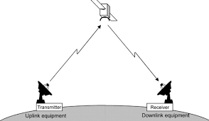

**Construction:**

The starting Stratellite was 188 feet larger, 60 feet wider and 42 feet height. It is provided with a new steering method which uses a hybrid electric system that drives large, slow- turning propellers.

They use thin-film photovoltaic cells sprayed on their surfaces to generate electricity, which drives propellers that work with GPS technology to keep the stratellite, located over one spot on the Earth's surface. 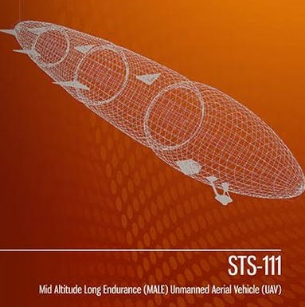

This gives the airship helicopter-like agility by being able to move both up and down, and side to side. The outside layer, or "envelope," is made out of a high-tech material called Spectra - a fabric used in bullet-proof vests and parts of space shuttles. Spectra contains fibre 10 times as strong as steel of the same weight and has the unique feature of being easy to cut but virtually impossible to tear.

**Working of Stratellite:**

* Inside is filled with Helium gas as it is inert gas not flammable.
* The Helium gas expands pushing out air and lifting the airship.
* Uses solar cells sprayed on their surface to generate electricity
* The generated electricity drives propellers that work with GPS technology to keep the stratellite stationary. Diagram

  Description automatically generated

**4th Generation Whale:**

* To achieve the goals of true broadband cellular service, the systems have to make the leap to a fourth-generation (4G) network. 4G is intended to provide high speed, high capacity, low cost per bit, IP based services. The goal is to have data rates up to 20 Mbps.
* The Stratellite will allow subscribers to easily communicate in both directions using readily available wireless devices.

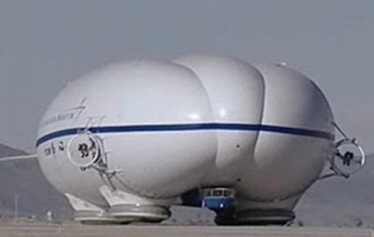

**Application:**

Once a Stratellite network is in place, it will provide a national broadband wireless network that will provide voice, video, and broadband internet access to all parts of the country. By linking several Stratellites together they can provide a wireless broadband network that will cover thousands of miles. With a Stratellite network, subscribers will be able to sit in their homes and be connected on their laptops to the internet at high speed. If subscribers need to go to the office, across town, or even to another city, they can close their laptop and take off, reopening the laptop at their new destination and still be connected to the internet. This would allow subscribers the ease of not having to find local access numbers, tie up phone lines, deal with modem hassles, and more importantly, slow speeds. In addition to internet use, "proposed telecommunications uses include cellular, 3G/4G mobile, MMDS, fixed wireless telephony, HDTV, real-time surveillance and others.

**Advantages:**

* Decreases Signal latency
* Less expensive to launch
* Service an area of 300,000 square-miles
* Two-way high speed data communication
* High speed broad-band access even in remote area.
* For a country two stratellites are enough instead of thousands of towers.

**Conclusion and future scope:**

Probably the most "far out there" concept in this roundup, Stratellite is actually much closer to reality than what you may think.

Stratelites provide the required facilities of wireless communication more efficiently than the ordinary towers. The Stratellite will allow subscribers to easily communicate in ‘both directions’ using readily available wireless technology.” They minimise the cost of communication. Stratellites present a mobile, low-cost, high-capacity alternative to satellite relays and cell towers. Once the defects of Stratellites have been overcome and become more reliable, they play a vital role in the future generation wireless communication.

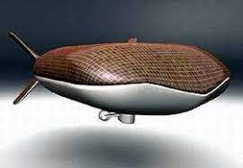

This is a promising technology that could combine the best of Satellite and wired Internet - fast with low latency and hugely widespread, at least in theory.